Home | About Us | Education | Connect | SHOP

SkillsUSA 2018
Competitions – SkillsUSA
54th Annual National Leadership & Skills Conference (NLSC)
Cosmetology SkillsUSA National Championships 2018
SkillsUSA Championship offers students of career and technical education the opportunity to demonstrate their leadership and hands-on occupational skills and receive recognition for their achievement. Winners advance from local competitions to district and /or state championships and finally to the national Skills USA Championship in Louisville, Kentucky at the end of June each year.
Nationals Schedule at a Glance
SkillsUSA 2018
Tuesday, June 26th
1:00 PM | Long hair mannequin pick-up
1:00 pm to 5:00 pm | Color long hair mannequins
Wednesday, June 27th
9:00 am to 12:00 pm | Color long hair mannequins – continued if needed
12:00 pm | Committee Meeting
1:00 pm | Registration for contestants
1:15 pm | Welcome, introduction of conference team, sponsors and judges, WorldSkills update
1:30 pm | Orientation and review of contest rules
2:30 pm | Written Test - Secondary  Oral Test - Post Secondary
3:00 pm | Written Test - Post Secondary  Oral Test –Secondary
4:00 pm | On-site visit

Thursday, June 28th
8:00 am | Registration (Kit check)
8:30 am | Introduction
8:45 am | Long Hair Overview
9:00 am | Long Hair (1 hour)
10:00 am | Judge Long Hair Design
10:30 am | Women's Cut and Design Overview
10:45 am | Women's Cut and Design (45 minutes)
11:30 am | Judge Women's Cut and Design
 | LUNCH
12:30 pm | Women's 90-degree Cut and Design Overview - Secondary  Men's Cut and Design Overview – Postsecondary
12:45 pm | Women's 90-Degree Cut and Design (45 minutes) - Secondary  Men's Cut and Design Overview – Postsecondary
1:30 pm | Judge Women's 90-Degree Cut and Design - Secondary  Judge Men's Cut and Design Overview – Postsecondary
2:00 pm | Women's 90-Degree Cut and Design Overview - Postsecondary  Men's Cut and Design – Secondary
2:15 pm | Women's 90-Degree Cut and Design (45 minutes) - Postsecondary  Men's Cut and Design (45 minutes) – Secondary
3:00 pm | Judge Women's 90-Degree Cut and Design - Postsecondary  Judge Men's Cut and Design – Secondary
3:30 pm | Grand finale parade  Final introduction of judges, committee members and sponsors
4:00 pm | Debriefing with Judges

2018 Contest Instructions
Mannequins
The technical committee will supply mannequins and holders. No make-up, eyelashes, jewelry or hair accessories are allowed on mannequins. If this changes in any given year, contestants will be told in advance to bring their own mannequins and holders.
The long mannequins will not be sent to participants like in previous years. These mannequins will be available for on-site picked up on the Cosmetology competition floor at the time stated. Competitors should mark their name on the bottom of the mannequin. Competitors will be allowed to color their long hair mannequins only on the competition floor during the times provided. Once the mannequin is colored, the competitor will turn in their mannequin for storage for the evening. Participants will not be allowed to take their mannequin with them off-site.
Competitors must bring all supplies required for their color application: color, lightener, developer, bowls, brushes, bottles, gloves, foil, protective crème & plastic wrap to prevent color staining of the mannequin’s skin, shampoo & conditioner, coil cotton and any other items needed. There will be shampoo bowls on site, but no heat source for processing. Students should use their blow dryers as a source of heat if required. Please note, the color tools & supplies are needed for the color application only. They are not part of the kit check list required on the day of competition.
Orientation Meeting – Written & Oral Tests
Orientation meeting, written & oral tests are conducted on the Wednesday before the competition. All competitors must create a one-page résumé and submit a hard copy to the technical committee chair at orientation. Failure to do so will result in a 10-point penalty.

Note: Your contest may also require a hard copy of your résumé as part of the actual contest. Check the Contest Guidelines and/or the updates page on the SkillsUSA website: www.skillsusa.org/compete/updates.shtml

The contest rules are reviewed as well as clothing requirements. Contestants will be escorted to contest site once the written test and oral communications test have been administered. Once contestants are familiar with the site and receive final instructions they will receive their gifts from the sponsors of the contest and will be free to leave for the day.

SkillsUSA Test: Used as a tie-breaker only. Subject matter-SkillsUSA Championships.
Parade Finale
Once the contest has been completed, contestants will be asked to provide some information to the commentator on a sheet of paper. Please type using 14-point typeface and print out the following information before arriving to SkillsUSA. Below is a sample:
Name:
School:
Advisor:
City/State: “Chicago, IL” (sample)
State slogan: “The Land of Lincoln” (sample)
Contestant will be asked to select from their completed mannequins and present them to the audience and judges during the parade finale.
Announcement of Winners
1st, 2nd and 3rd place winners for Secondary and Post-Secondary winners will not be announced until the Awards Ceremony. Sponsor prizes for these winners will be shipped to their home addresses compliments from the Technical Committee.
Uniform Layer (90-Degree) Haircut Procedure
Contestants must be able to duplicate a uniform layer (90-degree) haircut and design selected by the National Tech Committee. Contestant will style the hair with blow dryer and fingers only. Steps must be followed in the exact order.
Please also refer to the April 15th SkillsUSA Standards Update.
- Time allotted – 45 minutes
- 200 possible points – cut and blow dry will be scored
- Tools assembled and station prepared
- Create a four-section parting
- Drop a hairline (perimeter) guide
- Establish the design length around the back perimeter
- Establish the design length around the front perimeter
- Establish the interior guide at the top of the head (apex, crown)
- Continue cutting guideline to front hairline
- Continue cutting guideline from crown to nape
- Use vertical partings to blend top guide to design line
- Maintain a constant 90-degree elevation throughout the procedure
- Follow a traveling guide to maintain uniformly layered lengths
- Perform a cross check of procedure for accuracy
- Check perimeter guideline and finish as necessary
- Finished cut is uniformly blended
- Blow hair dry to frame face
- Clean and organize station

All of the following images below will be selected for the Cuts and Style contest at Nationals
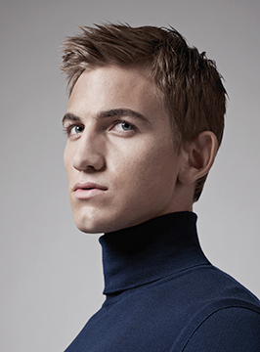 | 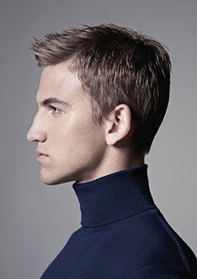 |  | Men’s Cut: Technical can be found in Pivot Point’s Meta:MEN – Page 106
 | 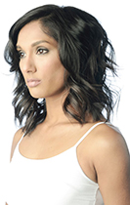 |  | Ladies Cut: Technical can be found in the  Milady Standard Haircutting System –  Mid-Length Layers – Page 98

Mannequins that will be used at Nationals:
- Ladies': Marianna – Ms. Suzi-Kin
- Men's: Pivot Point – Cole (Code: MLMGIDML-8)
- Long Hair: Burmax – Zoey (Code: 450)

